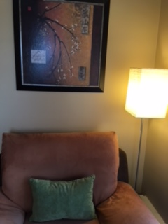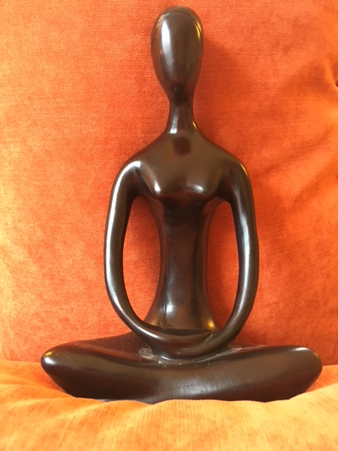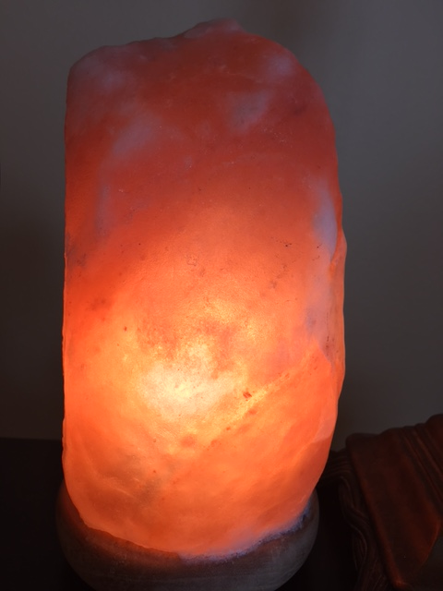

Mindfulness Skills

Have you ever wanted to quiet the mind, stabilize overwhelm or to work through issues in a deeper way? This is a group to develop these skills.

Self -disclosure is not necessary in this group setting. Instead we will focus on developing tools that you can apply to your life and individual sessions. It will facilitate and compliment your therapy.

Price is $40/hour twice/month for 3 months.

Individual Sessions

Robin Kahler, LMSW

734-645-0580

Robin Kahler, LMSW

1817 W. Stadium, Suite I

Ann Arbor, MI 48103

(734) 645-0580

[Web Address]

Trauma Informed Meditation

This group will address the main difficulties that people have when sitting to meditate including racing thoughts, boredom, sleepiness, physical discomfort, lack of time, and difficulty letting go.

The group will also address how to adjust ones’ meditation practice if there is a trauma or dis-regulation.

$40/hour weekly / 3 months

## Praesent congue sapien sit amet justo.